UNIT 5
Q1) Explain K-Nearest Neighbor algorithm with example.
The K-Nearest Neighbor (K-NN) algorithm is a supervised machine learning method used for classification and regression tasks. It is a non-parametric and lazy learning algorithm, meaning it does not make assumptions about the underlying data distribution and delays computations until prediction.
How K-NN Works
1. Data Storage: K-NN stores the entire training dataset for predictions.
2. Distance Calculation: When a new data point needs to be classified or predicted, K-NN calculates the distance between the new point and all points in the training data using a distance metric like:
3. Euclidean Distance: 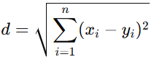
4. Manhattan Distance: 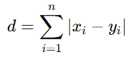
5. Finding Nearest Neighbors: Select the K closest data points (neighbors) to the new point based on the distance metric.
6. Majority Voting (for Classification): Assign the class that is most common among the K neighbors.
7. Averaging (for Regression): Take the average value of the target variable among the K neighbors.
8. Prediction: Use the result from majority voting (classification) or averaging (regression) as the final output.
Example: Classification Using K-NN
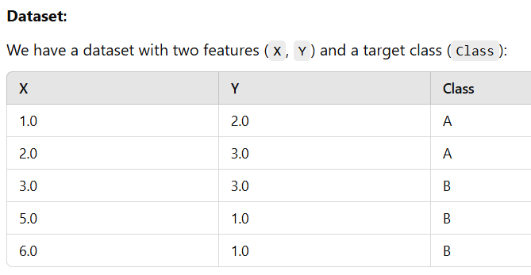
New Data Point: Predict the class of the point (4.0, 2.0) with K=3.
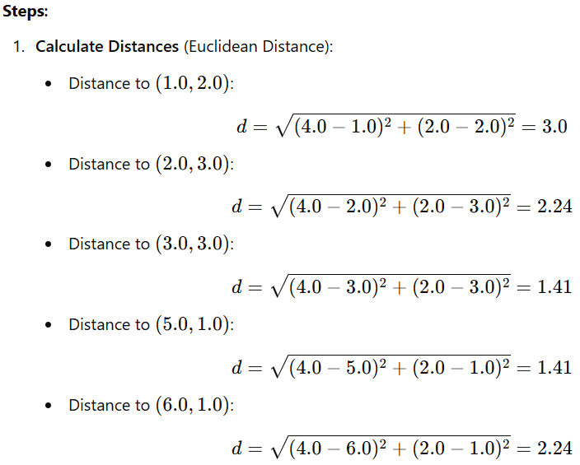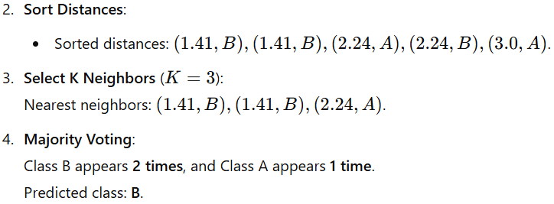
Advantages of K-NN
- Simple and intuitive.
- No training phase; works well with a small dataset.
- Effective for non-linear data distributions.
Disadvantages of K-NN
Computationally expensive for large datasets (distance calculation).
Sensitive to irrelevant or redundant features.
Choosing the optimal value of KKK can be challenging.
Applications of K-Nearest Neighbor (K-NN)
Text Classification: Used in spam detection, sentiment analysis, and document categorization.
Image Recognition: Identifying objects, faces, or handwritten characters.
Recommendation Systems: Suggesting movies, products, or music based on user preferences.
Medical Diagnosis: Classifying diseases or conditions based on patient symptoms or test results.
Fraud Detection: Identifying fraudulent transactions by comparing with past patterns.
---------------------------------------------------------------------------------------------------------------------------------------------------
Q2) Explain of the following terms: i) Medoid OR ii) Dendrogram
Dendrogram
Definition: A dendrogram is a diagram representing a tree or hierarchy.
It is a branching diagram representing a hierarchy of categories based on degree of similarity or number of shared characteristics.
Key Components of a Dendrogram:
Leaves: Represent individual data points at the bottom level.
Branches: Show how data points or clusters are merged.
Height: Indicates the level of dissimilarity or distance at which clusters are combined.
For example, the Fig. illustrates a simple dendrogram for six observations.
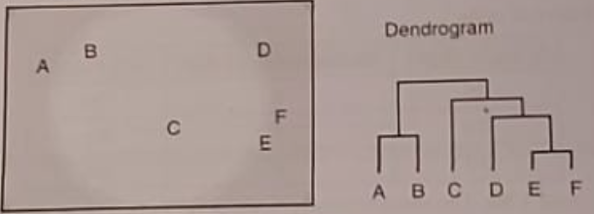
The key to interpreting a dendrogram is to focus on the height at which any two objects are joined together.
The height of the dendrogram indicates the order in which the clusters were joined
Dendrogram is a summary of the distance matrix, and, as occurs with most summaries, information is lost.
Applications of Dendrograms:
Gene Analysis: In bioinformatics, used to understand gene expression patterns.
Market Research: Clustering customers based on buying behavior.
Data Exploration: Visualizing relationships and hierarchical structures in datasets.
Medoid
A medoid is a representative data point in a dataset, used particularly in clustering algorithms like K-Medoids or PAM (Partitioning Around Medoids). It is the point within a cluster that minimizes the total dissimilarity (or distance) to all other points in the cluster. Unlike a centroid (which is a mean and may not be a real data point), a medoid is always an actual observation from the dataset.
Key Characteristics of a Medoid:
Representative Point: It represents the center of a cluster and is a member of the dataset.
Minimizes Dissimilarity: It minimizes the sum of distances between itself and all other points in the cluster.
Robust to Noise: Medoids are less affected by outliers compared to centroids.
Steps in the Working of a Medoid:
1. Initialization: Randomly select k points (medoids) as the initial centers.
2. Assignment: Assign each data point to the nearest medoid based on a distance metric (e.g., Euclidean distance or Manhattan distance).
3. Recalculation: For each cluster, calculate the total distance from each point to all others in the cluster. The point with the minimum total distance becomes the new medoid.
4. Repeat: Steps 2 and 3 are repeated until medoids no longer change or a stopping criterion is met.
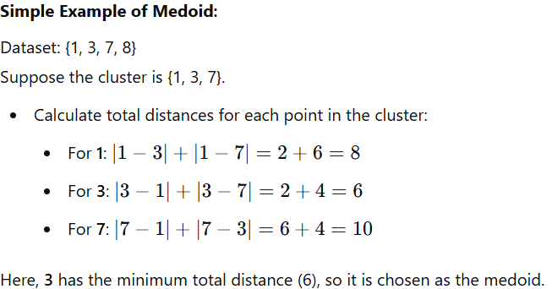
---------------------------------------------------------------------------------------------------------------------------------------------------
Q3) Explain the Apriori algorithm in. Explain the following performance measure of association rule mining.
1) Support 2) Confidence 3) Lift
Apriori Algorithm
Definition: Apriori is an algorithm for finding frequent itemsets.
- It works on the principle that “if an itemset is a frequent itemset then its subsets must also be frequent”. This is also called Apriori principle. It uses this principle to prune (or discard) all the itemsets that do not match the minimum required support threshold value.
- Extracting association rules (also called as association rule mining) from large datasets requires that you
1. Generate frequent itemsets and then
2. Generate association rules for those frequent itemsets.
This can be very expensive in terms of computation power required as the number of items grow.
- Apriori algorithm helps you to carry out the first step of association rule mining that is finding the frequent itemsets from the dataset.
Steps of the Apriori Algorithm:
1. Input:
Transaction database (e.g., a list of items bought in various transactions).
Minimum support threshold (to identify frequent itemsets).
2. Initialization:
Start with 1-itemsets (individual items) and calculate their support (frequency of occurrence).
Retain only those 1-itemsets whose support is greater than or equal to the minimum support threshold.
3. Generate Candidate Itemsets:
For k-itemsets, generate (k+1)-itemset candidates by combining frequent k-itemsets.
4. Prune: Eliminate candidates that have infrequent subsets, as these cannot be frequent by the Apriori property.
5. Count Support: Count the occurrences of remaining candidates in the dataset.
6. Repeat: Repeat the process until no more frequent itemsets can be generated.
7. Generate Association Rules: Use frequent itemsets to generate rules that satisfy the minimum confidence threshold.
Example:
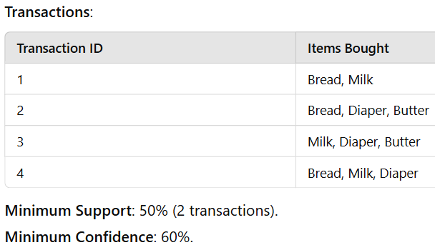
Steps of the Apriori Algorithm:
1. Find 1-itemsets:
Calculate the support for each item individually:
Bread: 3/4 = 75%
Milk: 3/4 = 75%
Diaper: 3/4 = 75%
Butter: 2/4 = 50%
Since all items meet the minimum support (50%), they are frequent 1-itemsets:
1-itemsets: {Bread}, {Milk}, {Diaper}, {Butter}
2. Generate 2-itemsets:
Combine the frequent 1-itemsets to form pairs and calculate their support:
{Bread, Milk}: 2/4 = 50%
{Bread, Diaper}: 2/4 = 50%
{Milk, Diaper}: 2/4 = 50%
{Milk, Butter}: 2/4 = 50%
{Diaper, Butter}: 2/4 = 50%
All of these meet the minimum support, so they are frequent 2-itemsets.
3. Generate rules:
From the frequent 2-itemsets, generate association rules and evaluate confidence:
Example: For {Bread, Milk}:
Rule: Bread → Milk
Confidence = Support (Bread ∩ Milk) / Support (Bread)
Confidence = 50% / 75% = 67%
If the confidence is greater than or equal to the minimum confidence (60%), the rule is valid.
1) Confidence
Definition: Confidence measures how likely a consequent is true for a given antecedent.
In simple words, confidence measures how likely ¹ is that an item Y is also purchased when item X is purchased. It is calculated as the ratio of support for itemset (X, Y) to support of itemset (X).
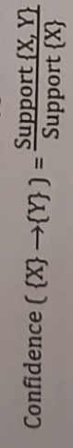
Confidence is a measure of an association rule where any itemset can be on the left-hand side (as antecedent) and any itemset can be on the right-hand side (as consequent). It may not just be limited to one item each on the left-hand side and right-hand side.
Example: If Bread → Milk has a support of 50% and Bread alone has a support of 75%, then Confidence(Bread → Milk) = 50% / 75% = 67%.
2) Lift
Definition: Lift measures how likely a consequent is true for a given antecedent while accounting for the popularity of the consequent.
In simple words, it measures how likely is that item Y is purchased when item X is purchased, factoring the popularity of Y into account. A lift value greater than 1 means that Item Y is likely to be bought if item X is bought, while a value less than 1 means that item Y is unlikely to be bought if item X is bought. ¹

Note here that the lift value that you get is not a percentage of confidence as such. It is just a measure to check the correctness of an association rule and you infer the outcome based on the lift value.
- Lift value > 1: Favorable (likely true) outcome
- Lift value < 1: Unfavorable (unlikely) outcome
It is calculated as
Example: If Confidence (Bread → Milk) = 67% and Support(Milk) = 75%, then Lift(Bread → Milk) = 67% / 75% = 0.89.
3) Support
Definition: Support measures the frequency of a given itemset in the dataset (amongst all transactions).
It is measured as the ratio of the number of transactions that contain the itemset to the total number of transactions in the dataset. For example, (Bread) appears in all the transactions.
Definition: Support Threshold helps you to choose significant itemsets and ignore others. So, if an itemset has a very low support, then you do not have enough information on its relationship with other itemsets in the dataset and hence you cannot draw any meaningful conclusions.
Example: In the above dataset, Support(Bread, Milk) = 2/4 = 50%.
4) Leverage
There is another measure called leverage that is sometimes used to check statistical independence of the two items.
Definition: Leverage measures the difference in the probability of X and Y appearing together in the dataset compared to what would be expected if X and Y were statistically independent of each other.
It's calculated as: Leverage (X → Y) = Support (X, Y) - Support (X) × Support (Y)
If leverage is 0, then it means that X and Y are statistically independent of each other.
If leverage is greater than 0, it means that X and Y have some kind of relationship with each other.
Larger the leverage, stronger is the relationship between X and Y.
Frequent 2-itemsets:
{Bread, Milk}: Support = 2/4 = 0.5
{Bread}: Support = 3/4 = 0.75
{Milk}: Support = 3/4 = 0.75
Calculate Leverage for Rule: Bread → Milk
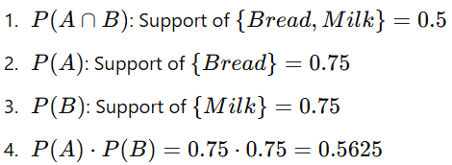
Leverage:
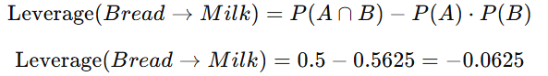
Interpretation:
The leverage value for Bread → Milk is -0.0625, indicating that the items Bread and Milk occur slightly less often together than expected if they were independent.
5) Minority Class:
In Machine Learning: The minority class refers to the class in a dataset that has significantly fewer samples compared to the majority class. This is common in imbalanced datasets, such as fraud detection, where fraudulent transactions (minority class) are much fewer than non-fraudulent ones (majority class).
Example: In a dataset with 10,000 transactions, if 9,500 are labeled as "not fraud" and 500 as "fraud," the "fraud" class is the minority class.
In Association Rule Mining: The minority class refers to the less frequent itemset or category within the transactional dataset. Association rules aim to discover relationships between itemsets, and rules involving minority classes can indicate rare but potentially valuable patterns.
Example: In a supermarket dataset, if "butter" is purchased much less frequently than "milk," then "butter" represents a minority item, but its association with "bread" might still yield significant rules.
---------------------------------------------------------------------------------------------------------------------------------------------------
Q4) Explain the following distance metrics with example.
1) Euclidean Distance 2) Manhattan Distance 3) Hamming Distance
1. Euclidean Distance
The Euclidean distance between two points in Euclidean space is the length of a line segment between the two points.
It is the most commonly used distance metric in machine learning.
It can be calculated from the Cartesian coordinates of the points using the Pythagorean theorem. It is thus also occasionally called the Pythagorean distance.
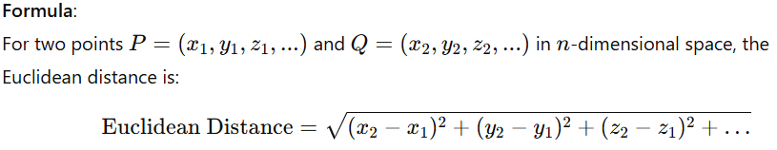
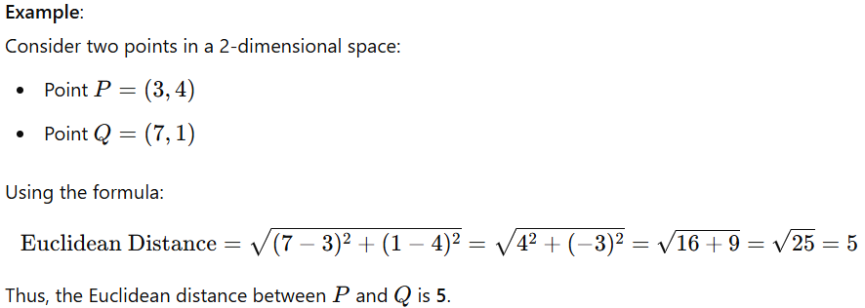
2. Manhattan Distance
Definition: Manhattan Distance is the distance between two points measured along axes at right angles.
Manhattan distance is a form of taxicab geometry. In taxicab geometry, the distance between the two points is the sum of the absolute differences of their Cartesian coordinates.
The taxicab metric is also known as rectilinear distance, L1 distance, L¹ distance or l₁-norm, snake distance, city block distance, Manhattan distance or Manhattan length.
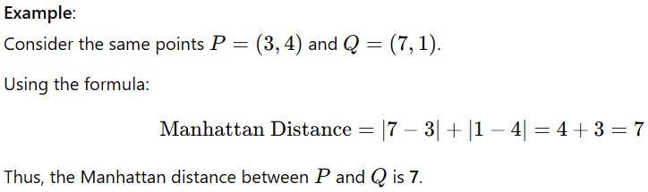
3. Hamming Distance
Definition: Hamming distance is used to measure the difference between two strings of equal length. It is the number of positions at which the corresponding elements (characters) are different. It is typically used in coding theory to measure the error between two strings (or sequences) of bits.
In other words, it measures the minimum number of substitutions required to change one string into the other, or the minimum number of errors that could have transformed one string into the other.
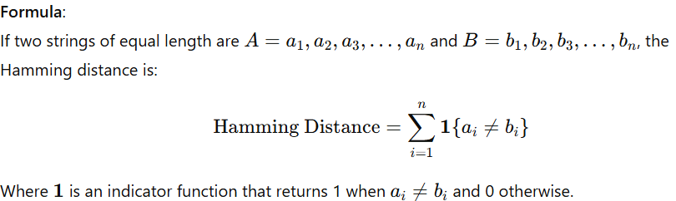
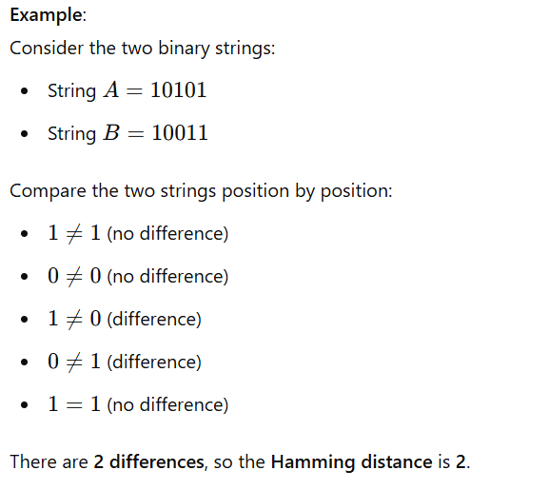
---------------------------------------------------------------------------------------------------------------------------------------------------
Q5) K-Means Algorithm , Centroid , Rule
K-Means Algorithm
Definition: K-Means is a popular unsupervised machine learning algorithm used for clustering tasks. It partitions a dataset into K clusters based on feature similarity. The goal is to minimize the variance within each cluster, making the data points in each cluster as similar as possible while keeping the clusters as different from each other as possible.
Use of K-Means :
1. Customer Segmentation: In marketing, K-Means is often used to segment customers based on their behavior and preferences. For example, segmenting customers based on purchase history, demographics, or web activity to tailor marketing strategies and offerings.
2. Anomaly Detection: K-Means can help identify anomalies or outliers in a dataset. Data points that do not fit well into any of the clusters are considered outliers. This is useful in fraud detection or network security.
3. Pattern Recognition: K-Means is used for pattern recognition tasks, where the goal is to identify groups or clusters in data. For example, grouping similar shapes or patterns in image processing.
4. Market Basket Analysis: K-Means can be used to find patterns in shopping cart data by grouping products frequently bought together. This helps in understanding customer preferences and in inventory management.
5. Speech Recognition: K-Means can be used in speech recognition systems by clustering features extracted from speech signals. This helps in categorizing sounds or words for better recognition.
Working of K-Means Algorithm:
The K-Means algorithm follows these basic steps:
1. Initialization: Select KKK initial centroids (either randomly or using some heuristic method). These centroids can be thought of as the "center" of each cluster.
2. Assignment Step: Assign each data point to the nearest centroid. This is usually done by calculating the Euclidean distance between each data point and the centroids. Each point is assigned to the cluster whose centroid is the closest.
3. Update Step:
After all points are assigned to a cluster, update the centroid of each cluster. The new centroid is the mean of all the points in the cluster.
4. Repeat Steps 2 and 3:
Repeat the assignment and update steps until convergence, which occurs when the centroids no longer change or the change is minimal.
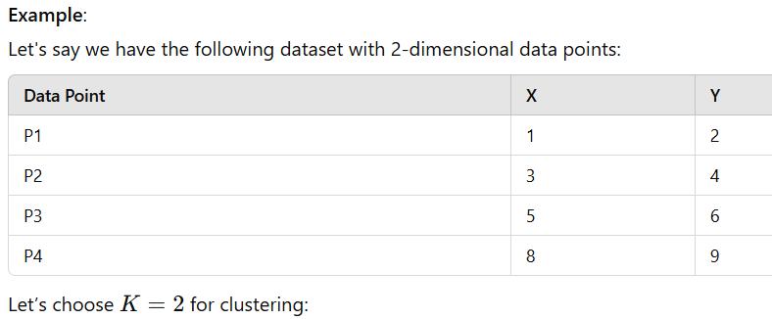
1. Initialization: Select initial centroids (randomly or heuristically, let's say C1=(1,2) and C2=(8,9).
2. Assignment Step: Assign each point to the closest centroid. After the first iteration, points close to C1C_1C1​ (like P1, P2) will be assigned to it, and points close to C2​ (like P3, P4) will be assigned to it.
Update Step: Compute new centroids:
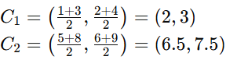
Repeat: Repeat the assignment and update steps until centroids converge.
Centroid:
The centroid of a cluster is the arithmetic mean of all the data points in the cluster. In other words, it's the point whose coordinates are the average of the coordinates of all the points in the cluster. Centroids are used in K-means because they help in calculating the "center" of the cluster. The centroid minimizes the sum of squared distances from all points in the cluster to the centroid.
Example:
For a cluster with points (1,2), (3,4), and (5,6), the centroid would be:
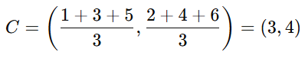
Rule: In machine learning, a "rule" typically refers to a decision-making statement or condition derived from data. It can represent a relationship between input features and output predictions. Rules are often used in classification and decision tree algorithms.
Explanation: In supervised learning, a rule is a logical expression that maps the input features to a predicted output. For example, in a decision tree, each split corresponds to a rule that separates the data into different branches based on certain feature values.
A rule may be in the form: If (Condition) Then (Prediction)
Example: "If age > 50 and income > 100K, then the person is a high-value customer."
In association rule mining, a rule can be written as: If A, Then B
For example: If a customer buys "Bread", Then they are likely to buy "Butter".
---------------------------------------------------------------------------------------------------------------------------------------------------
Q6) State & explain with appropriate example different types of linkage use in clustering?
The concept of linkage comes when you have more than 1 point in a cluster and the distance between this cluster and the remaining points/clusters has to be figured out to see where they belong.
Linkage is a measure of dissimilarity between clusters having multiple observations.
The types of linkages that are typically used are:
1. Single Linkage 2. Complete Linkage
3. Average Linkage 4. Centroid Linkage
The type of linkage used determines the type of clusters formed and also the shape of the dendrogram.
1. Single Linkage (Nearest Point Linkage)
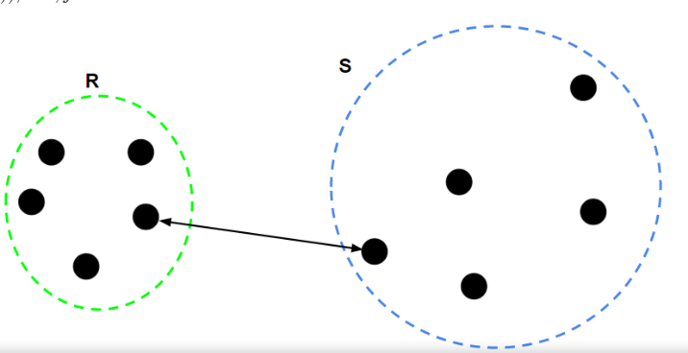
Definition: In single linkage, the distance between two clusters is defined as the shortest distance between any two points in the clusters. It is also known as the "nearest point" method.
How it works: For two clusters, the distance between them is the minimum distance between any pair of points, one from each cluster.
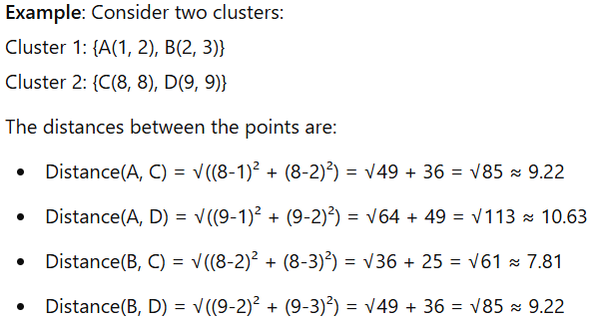
Linkage Distance: The single linkage distance between Cluster 1 and Cluster 2 would be the minimum of all the pairwise distances: Distance = 7.81 (from B to C).
Characteristics:
Tends to form "chained" clusters where new points are added to the existing cluster.
Sensitive to outliers, as a single point can link two faraway clusters.
2. Complete Linkage (Farthest Point Linkage)
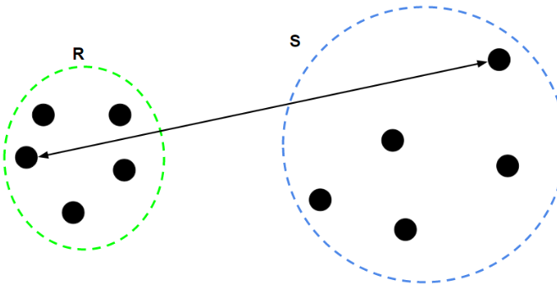
Definition: In complete linkage, the distance between two clusters is defined as the maximum distance between any pair of points, one from each cluster. It is also known as the "farthest point" method.
How it works: For two clusters, the distance between them is the maximum distance between any pair of points, one from each cluster.
Example: Using the same clusters as in the previous example:
Linkage Distance:
The complete linkage distance between Cluster 1 and Cluster 2 would be the maximum of all the pairwise distances: Distance = 10.63 (from A to D).
Characteristics:
Tends to form compact and spherical clusters.
Less sensitive to outliers than single linkage.
3. Average Linkage (Group Average Linkage)
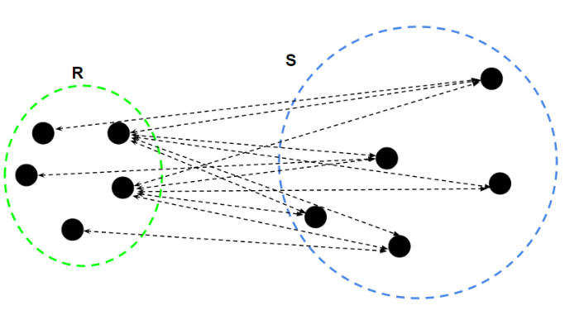
Definition: In average linkage, the distance between two clusters is defined as the average of the distances between all pairs of points, one from each cluster.
How it works: For two clusters, the distance is the average of all the pairwise distances between points in the two clusters.
Example: Using the same clusters:
Pairwise Distances: Distance(A, C) = 9.22
Distance(A, D) = 10.63
Distance(B, C) = 7.81
Distance(B, D) = 9.22
Linkage Distance: Average Distance = (9.22 + 10.63 + 7.81 + 9.22) / 4 = 36.88 / 4 = 9.22
Characteristics:
Tends to be a compromise between single and complete linkage.
Works well when the clusters are of similar size and shape.
4. Centroid Linkage
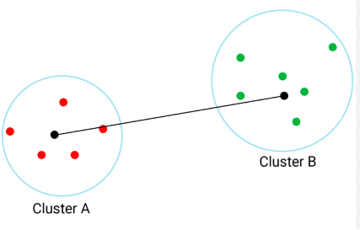
Definition: In centroid linkage, the distance between two clusters is defined as the distance between their centroids (the mean of the points in the cluster).
How it works: For two clusters, calculate the centroid (mean) of each cluster, and then compute the distance between these centroids.
Example: If Cluster 1 has points A(1, 2) and B(2, 3), the centroid of Cluster 1 is (1.5, 2.5). If Cluster 2 has points C(8, 8) and D(9, 9), the centroid of Cluster 2 is (8.5, 8.5).
The distance between the centroids is: Distance = √((8.5-1.5)² + (8.5-2.5)²) = √(49 + 36) = √85 ≈ 9.22
Characteristics:
Generally more stable and consistent than other methods.
Can sometimes fail when the centroids are not representative of the clusters.
---------------------------------------------------------------------------------------------------------------------------------------------------

